Charles Sharp
Logan Rook
Lauryn Curtiss
Wade Ratzlaff
System Design Reverse-Engineering Lab
System to Analyze: Adobe Photoshop
- Problem the Product Solves: Adobe Photoshop removes creative barriers by giving users powerful tools to transform, enhance, and reimagine their photos. It streamlines the entire design process so ideas can move from imagination to polished digital artwork with ease.
- Core Features
  - AI Powered Editing
    - Automates tasks like sky replacement, object removal, and image harmonization to speed up creative workflows
  - Layers
    - Lets users stack, edit, and organize different elements independently for flexible, non-destructive editing
  - Selection Tools
    - Has tools like Quick Selection and Magic Wand to isolate and edit specific parts of an image
  - Adjustment Layers
    - Allows color correction, brightness/contrast changes, and other edits without permanently altering the original image
  - Retouching Tools
    - Features like the Healing Brush and Clone Stamp help users remove blemishes, fix imperfections, and refine photos
- Non-Functional Requirements
- High Speed Performance/Low Latency - In dealing with large files and photo editing, it is important to make sure the program should respond quickly for all features as editors want immediate feedback on all features; delays can be frustrating.
- Scalability - Photoshop is something that can implement many features, and as it adds those, it needs to handle large data information, extra tools(especially AI) and user traffic.
- Availability - Similar to performance, Photoshop needs to be able to access cloud data, download files, and export and import files effectively and efficiently.
- Durability - Edits can take a long time to make, so it is important for the app to save files in case of network failure, app crashes, or when save features fails. Users need to know their work is safe.
- Security - Accounts, files, and account access needs to be protected from unauthorized access. The system needs to have some sort of encryption and secure APIs.

- Architecture Diagram
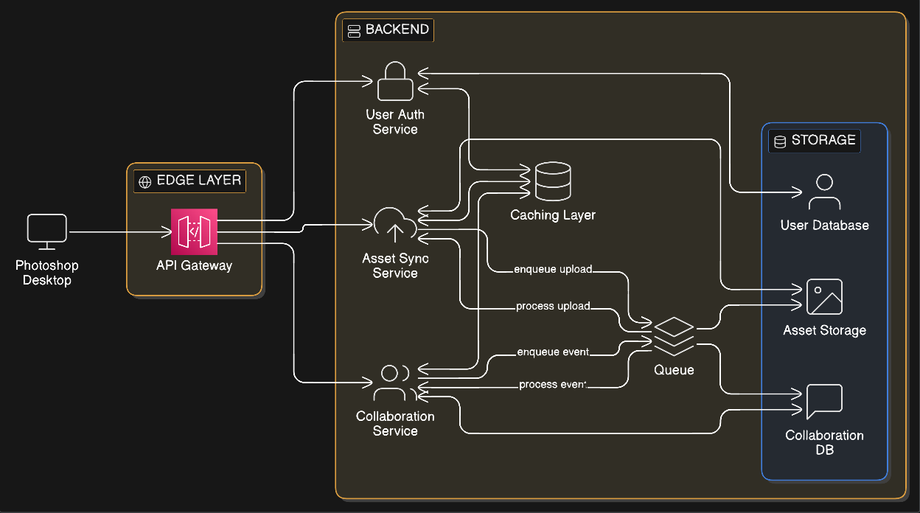

- Data Flow for One Critical Action
User Action: Editing (Photoshopping) a Photo in Adobe Photoshop
Step 1: Open Photoshop
The user launches Adobe Photoshop on their computer.
Step 2: Open the Image
The user clicks File → Open, then selects the photo file from their computer.
Step 3: Load Image into Workspace
Photoshop displays the photo in the main editing canvas.
Step 4: Select an Editing Tool
The user chooses a tool from the toolbar, such as the Crop Tool, Brush Tool, or Clone Stamp Tool.
Step 5: Make Edits to the Photo
The user applies changes (for example: cropping the image, removing blemishes, adjusting colors, or adding text).
Step 6: Preview Changes
The user views the updated image in real time to see how the edits look.
Step 7: Adjust if Needed
If the result is not correct, the user can undo changes or try different tools and adjustments.
Step 8: Save the Edited Photo
The user clicks File → Save As, chooses a file format (such as JPG or PNG), and saves the edited image to their computer.
Step 9: Close the File or Continue Editing
The user either closes the project or continues making more edits

- Failure Modes and Mitigation
- Crashing While Editing - One issue that could happen is Photoshop crashing when editing. Any unsaved edits could get lost. Some system mitigations would be version history and autosave.
- Overloading the Backend- The problems with backend overload, would happen because too many users could be accessing cloud documents or using premium features at once. A way to fix this would be rate limiting and load balancing.
- Data Corruption - A storage layer issue could damage documents and files, causing them to be inaccessible. This can be mitigated by having integrity checks and replicated storage.
- Auth failure - What happens when user login fails? Users could be locked out of their account or of cloud information. To prevent this, there can be account recovery or multiple auth tries.
- Cloud syncing failure - Cloud syncing is a way for Photoshop to get all files it needs and keeps them from getting deleted. If it doesn’t sync them to the cloud they could get lost. A great way to make sure users know this is having a sync status indicator.
- Unknowns and Assumptions:
01 Rendering pipeline architecture [Render]
What we don't know | Best guess | How to verify
Whether Photoshop uses a retained-mode scene graph, an immediate-mode compositor, or a hybrid tile-based system for compositing layers onto the canvas. | Likely a tile-based compositor — tiles allow dirty-region invalidation so only changed areas re-render. Possibly backed by Metal (macOS) or Direct3D (Windows) via an abstraction layer. | Use Activity Monitor GPU history while painting. Profile with Instruments → Metal System Trace (macOS) or PIX (Windows) to capture draw calls. Check Adobe's developer docs for "Mercury Graphics Engine" architecture.
02 Memory management and tile caching [Memory]
What we don't know | Best guess | How to verify
How Photoshop decides when to swap layer data to disk scratch space vs. keeping it in RAM, and what data structure governs the tile cache. | An LRU (least-recently-used) cache of fixed-size tiles (likely 64×64 or 128×128 px). Scratch disk acts as an overflow page file; tiles are evicted based on last-access time. | Monitor scratch disk I/O with iostat or Task Manager Disk column. Open huge documents and watch RAM in Activity Monitor. Check Preferences > Performance > Cache Levels and tile sizes — Adobe exposes these knobs.
03 Plugin and CEP extension isolation model [Plugin]
What we don't know | Best guess | How to verify
Whether third-party plugins (C++ API) run in-process or in a separate sandboxed process, and how UXP extensions are isolated from the host app. | Legacy C++ plugins are almost certainly in-process (hence one bad plugin can crash Photoshop). UXP extensions likely run in a Chromium-based sandbox subprocess, communicating over IPC. | Open a UXP plugin, then inspect running processes in Activity Monitor or Process Explorer. Look for child processes with "CEF" or "UXP" in their name. Check lsof for Unix domain sockets or named pipes between processes.
04 Color management pipeline [Color]
What we don't know | Best guess | How to verify
At what point in the rendering pipeline ICC profile transforms are applied — per-layer, at composite time, or only at display output — and whether GPU shaders handle the transforms. | Most transforms likely happen at display output using Little CMS (LCMS) or a proprietary equivalent, with GPU-accelerated display transform on Metal/DirectX. Per-layer transforms only on explicit profile assignments. | Assign a mismatched ICC profile mid-layer, then capture GPU commands with Metal System Trace. Search Photoshop's binary for lcms or ColorSync symbols using nm or strings on the executable.
05 History state / undo data structure [Undo]
What we don't know | Best guess | How to verify
Whether history states store full pixel snapshots, structural diffs, command objects (command pattern), or a combination — and how non-destructive adjustments factor in. | A hybrid command-pattern + delta approach. Lightweight edits store command objects; destructive pixel operations store compressed tile deltas. Non-destructive layers store parameter diffs only. | Perform a large paint stroke, then watch RAM and scratch disk jump. Undo it and see if RAM drops immediately. Compare PSD file sizes before and after 50 history states — large growth suggests snapshot storage. Export as XMP/PSB and inspect the structure.
06 PSD / PSB internal file format layout [File format]
What we don't know | Best guess | How to verify
Exact binary layout of PSD section headers, compression codecs used per section, and how Smart Object linked data is stored (embedded vs. referenced). | PSD is a documented but complex chunked format. Image data is RLE (PackBits) or raw. Smart Object data is likely an embedded sub-document blob using the same structure recursively. | Open a PSD in a hex editor (hexdump or ImHex). Adobe's PSD spec is publicly available at adobe.com/devnet-apps. Use psd-tools (Python library) to walk the layer resource blocks and print structure.
07 GPU acceleration boundaries (Mercury Graphics Engine) [GPU]
What we don't know | Best guess | How to verify
Which operations actually run on the GPU vs. CPU fallback — specifically which filters, blend modes, and transform operations have GPU shader implementations. | Transforms, warp, Liquify, and most blend modes are GPU-accelerated. Some legacy filters (certain noise/halftone) likely remain CPU-only. Complex filter chains may fall back to CPU to avoid shader complexity. | Disable GPU in Preferences → Performance → Use Graphics Processor, then benchmark the same operations. Time difference reveals GPU involvement. Capture GPU utilization with gpu-z (Windows) or Activity Monitor → GPU History (macOS) per operation.
08 Threading model and work dispatch [Threading]
What we don't know | Best guess | How to verify
Whether Photoshop uses a thread pool, a task graph, or per-feature threads; whether the main thread is the sole render coordinator; and how thread count scales with CPU core count. | Likely a fixed thread pool sized to logical core count, with tile-level parallelism for filters. Main UI thread dispatches work; results are collected synchronously before the next UI frame. Intel TBB or a similar work-stealing scheduler may be in use. | Run a multi-pass filter on a large document. Use Instruments → Time Profiler (macOS) or Process Explorer → Threads (Windows) to count live threads. Vary CPU core count in VM settings and measure throughput scaling. Check for tbb symbols in the binary.
Sources (Must have at least 5 credible sources)
Adobe. “All Photoshop Features.” Adobe, https://www.adobe.com/products/photoshop/features.html
Barbacci, Mario, et al. Quality Attributes. Software Engineering Institute, Carnegie Mellon University, 1995, https://www.sei.cmu.edu/documents/1142/1995_005_001_16427.pdf
Fritzsch, Jonas, et al. “From Monolith to Microservices: A Classification of Refactoring Approaches.” arXiv, 2018, https://arxiv.org/abs/1807.10059
Microsoft. “What’s New in the Azure Well-Architected Framework.” Microsoft Learn, Dec. 2025, https://learn.microsoft.com/en-us/azure/well-architected/what-is-well-architected-framework
Welsh, Matt, David Culler, and Eric Brewer. “SEDA: An Architecture for Well-Conditioned, Scalable Internet Services.” ACM Digital Library, 2001, https://people.eecs.berkeley.edu/~brewer/papers/SEDA-sosp01.pdf

